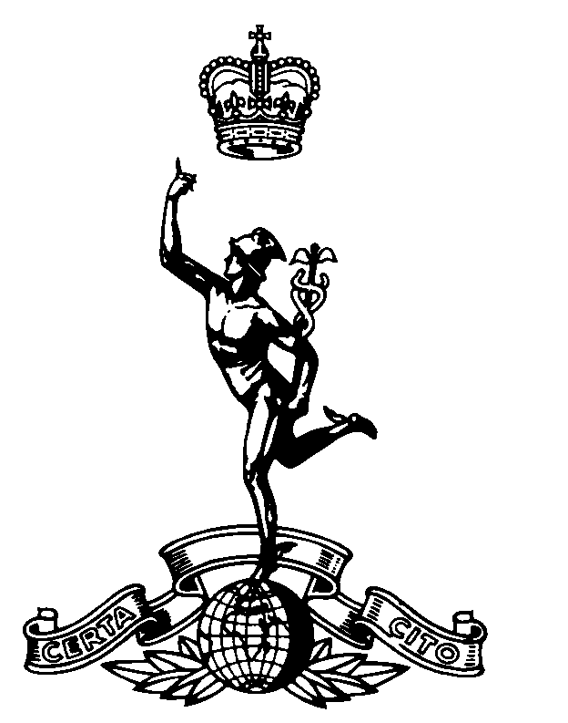
The Parachute
Signal Squadron 1948 - 1977
Old Comrades Association

OCA/6 S G Marshall MBE
44 High Road
Toton
Nottingham
NG9 6HE

6 August 2003 email: sgm216@lineone.net
Web: www.216parasigs.org.uk

Home: (0115) 8494607
Work: (0115) 9721825
Mobile: 07712 766843

A few lines by way of bridging the gap between my letter of December last year and the one I will send towards the end of November to start the ball rolling toward our next reunion weekend. Time drifts by and before we know it the weekend will be upon us. There is little to do at this stage other than consider travel arrangements and hotel reservations as applicable. I know that many have already done this but those who have not are advised to do so at the earliest to avoid disappointment. The Hotel Staff have agreed that, once they are full, they will ‘lay-off’ reservations to other accommodation in the immediate area. We do, however, expect even that to be taken-up rapidly. To this end, I enclose a booking form showing the preferential rates negotiated on your behalf; £28.00 per head per night (based on 2 people sharing) and £38.00 for a single room. The standard rate for 2004 is £60 per head per night so we think we did reasonably well! If you prefer not to use the form, a simple ‘phone call will secure the room/s with a card number only at this stage. The card will not be debited until the end of your stay.

Feedback from the 2002 Reunion was positive so we decided to change as little as possible. We have, however, opted for a buffet supper on the Saturday evening rather than dinner. The buffet will run for 2 hours (2100 – 2300) allowing those who want to eat and then get on with the main theme to do so. It will also serve to keep costs to a minimum. We hope you will be happy with these arrangements. The Golf Competition was a hit and we plan to do it again. This time Bob Mills gets to play off scratch!. All this and more in the November letter.

Our website is now up and running and those with the means are encouraged to access it and leave messages etc. on the Guest Notice Board. We’re pleased with the site as it continues to expand. It really will prove valuable in our efforts to get topical information to you in the future. I’m grateful to Keith Weller for all the work he has done (and is still doing) where this is concerned. At this stage, Keith is working on uploading some photo’s I’ve sent him. If you have any we can use, grateful you let me have them (please use recorded delivery); they will be returned once scanned into the system.

Ever on the lookout for past members of the Squadron, you will know from previous correspondence that we managed to track down Vic Zimmer. We haven’t heard much from Vic recently but I understand he was having computer problems out there in Queensland Australia so if you have been attempting to establish comms on that means, with a little luck, he’ll get back to you shortly. Thanks to the endeavours of Chris White and Tom Moorhouse, we’ve now made contact with Pete Thornton. Pete also lives in Queensland, is well and looking forward to keeping in touch with his old buddies. If you contact me, I can let you have his email and pony express address. Similarly, Hugh Smith put me in touch with Dave King who now works out of Spain. Dave hopes to come over for our next get-together and sends his best to all who knew him in Aldershot and beyond. Les Lawbuary has also come in from the cold - he too is living in Spain and we hope to see him in May next year. Les is happy that I pass his contact details to anyone who wants them – just give me a call.

Once again I have sad news; Pete Broad is no longer with us. Neither Ralph nor I were in a position to go to the funeral but I understand that Ivor Wells managed to attend. I have spoken to Denise who is keen to remain on the mailing list. In this way, we can ensure that she doesn’t entirely loose touch with the friends she made during Peter’s time in the Squadron.

Passing the wrong door at the right time (or the other way around), I found myself with the job of Secretary of the embryo Western on the Green (Airborne Signals) Branch of the Royal British Legion. John Griffin must have passed the same door since he is to be President. I am to attend a 2 day course in London, at which point I (presumably) find out what I have been doing wrong to date!. Once this has happened, a committee meeting to formally establish the Branch will be arranged. Thank you to those who volunteered to serve on the Committee; either Craig Treeby or I will contact you in due course to agree convenient dates/times. To those who completed applications/transfer forms, if you have not received your Membership Card yet, you soon will. Finally on this point, if anyone wishes to join, please contact me and I will make the necessary arrangements. We currently have 56 members which – I am told – is not bad for starters.

As I have said, full details of the 14/16 May 2004 Reunion Weekend will come out early in December. Meanwhile, a good number of you did not respond to my letter of last December asking for confirmation of address etc. We know that life is busy but – a plea from the organisers – do let us have any changes you may be aware of or that you see happening in the future (either in respect of yourself or others). It really would be a shame to loose touch simply because we don’t have an up-to-date address/telephone number. A ‘phone call to Ralph or to me will do it, leaving a voice message if necessary so that one of us can get back to you. Look forward to seeing you in the future.

Finally, as he retires after 38 years service, well done to Peter Whitehead on his appointment to OBE in the Birthday Honours List. Andy Starling’s wife, Cecilia, tells us that he has just left the Corps having completed 39 years service! – can anyone beat that? Enjoy your retirement Andy.

Regards

