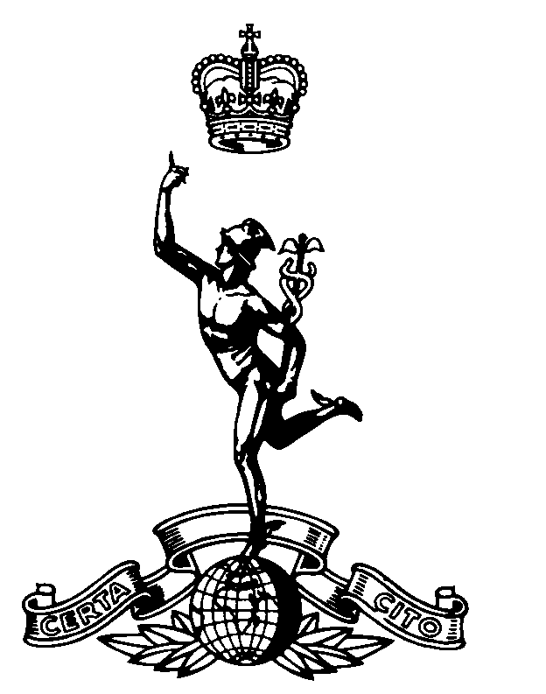
The Parachute
Signal Squadron 1948 - 1977
Old Comrades Association

OCA/5 S G Marshall MBE
44 High Road
Toton
Nottingham
NG9 6HE

17th December 2002 email: sgm216@lineone.net
Web: www.216parasigs.org.uk

Home: (0115) 8494607
Work: (0115) 9721825
Mobile: 07712 766843

Those who were there must surely agree that the weekend of 18th and 19th May should be consigned to legend. A magnificent affair and one even more successful than anyone could have imagined! So good to see everyone and to be part of something that many of us will remember for years to come. Such an event, how many faces from the past, so many stories, so many friends and so much fun. Time slipped rapidly by and I swear, come Sunday evening, the Hotel really was a much sadder place once you had all gone. Ralph and I have been overwhelmed by the tide of thanks received since the weekend - thank you all for that and for making our efforts (such as they were) worthwhile. Thanks also to the ladies for organising a raffle that produced a little over £1,000 on the day. Having paid all the overheads, we were able to walk away with around £200 in the bank. This will be carried forward to the next function. On your behalf we made a donation of £50 to the Hotel Staff in appreciation of their considerable input. I'm sure that the gesture will pay dividends.

Things have moved on apace. Ralph is very clear on one thing; the next one simply will not wait another 3 years. Accordingly, at a meeting in August at Scotch Corner, we set a date for our next reunion weekend - Friday 14th to Sunday 16th May 2004. This is 2 years, almost to the day, from this year's event and is now only 18 months away. Please make a very big diary note now. We believe that the Quality Hotel Scotch Corner looked after us so well this time that consideration of an alternative venue is not an option. Hopefully you agree since everything is now booked pending our return in January to confirm all detail. The Hotel's conferencing facility is to be made available for a buffet supper (as part of the main event) on the Saturday evening. We favour a buffet rather than dinner in anticipation of an even larger gathering in 2004; you will recall how near to bursting at the seams we were this year! Come January/February 2003, I will be able to let you know how our negotiations in respect of charges for accommodation, meals etc. have gone. Meanwhile, you can now think about making reservations - the Hotel will only need a card number at this stage. I will write in the New Year to begin the process of confirming attendance.
With any luck we will see the website by Christmas. The delay is entirely of my own making. I had to get authority from Colonel Mike Ayrton (the author of the only composite history of airborne signalling in existence) to use his book on the Site. He is now retired and living in France so this took some time. Having received his blessing, everything had to be converted into a format that Keith Weller will be able to use on the history page. Keith has been very patient but (I think) he now has all he needs. The holding page appears under the address on this letter; wait out!

Once again, I am the harbinger of bad news. You will know how poorly Harry Ruff was in May. He really made a gargantuan effort to attend the Reunion but I have to tell you that he finally succumbed in the summer. Harry's funeral took place in London on 29th August, a deeply moving affair attended by many. Some of his closest friends, were there; Chris Davison, Ron Tasker, Dickie Hudd, Blackie Blackmore and John Griffiths. Harry and I didn't serve together in the Squadron but over the years I met him and enjoyed his company - generally at reunions. He had been very close to my late brother-in-law, Dave Harvey, and I was keen to add my support to Maureen and her family at their most difficult time.

None of us can see what the future has in store so I make no apology for enclosing details of Craig Treeby's proposal for a branch of the Royal British Legion drawing its membership from the airborne signals fraternity. It will not be for everyone and most will - hopefully - never have need of the services that the Legion offers. However, in recent years, at first hand I have seen their work and how well they meet their charter when called upon. The advertisement now ends. I merely ask that you look at the detail and consider membership. Whatever you decide, I would be grateful for your views/response.

Our mailing list has become unmanageable in its current form. I would like to get everyone onto a decent database and, to that end have started expanding my 'Contacts' in Microsoft Outlook. It is probable that some of the information I hold is out of date. Perhaps you would be kind enough to spend a few minutes completing the enclosed questionnaire and return it in the pre-addressed envelop (same envelope as the RBL return). Once again, I have included a 'Wanted List' and would be grateful for any information you have in this respect. Ralph is in charge of searches and I like to keep him busy!. Incidentally, early days but he did come up with a website that may be useful to us in the future; http://www.comradesandcolleagues.com. 7 RHA, 9 Squadron, the battalions, Heavy Drop Company and other Brigade units appear but the Squadron doesn't figure and I am in the process of putting that right. The Webmaster's response suggests that, once he has confirmed our legitimacy, we will be included. When this is done, those on the Internet will be able to access the entry and insert their names/contact details. This really will be useful and a particularly effective tool as we search for the chosen in the future! While I'm on the subject, it was from a similar source that Chris White managed to contact Vic Zimmer who is now firmly on board. Many who knew Vic will be pleased about this latest find and we all look forward to seeing him in 2004 - all the way from Aussie!. If you want to contact Vic he would be delighted to hear from you; email address below.

It remains now to wish you all well for the Festive Season, Ralph and I trust that this letter finds you and yours in good shape. We hope to hear from you soon.

Vic's email: erivic@mail2me.com.au

