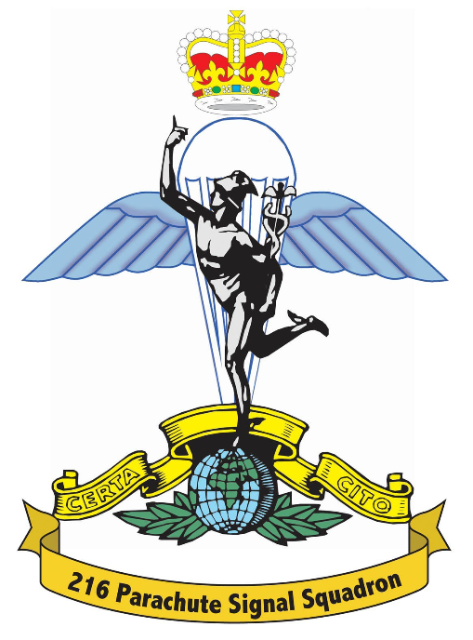
Ralph Porter
10 Lanhorne Drive
Reeth
Richmond
North Yorkshire
DL11 6ST

Home: 01748 884684
Mobile: 07732 042794

THE PARACHUTE SIGNAL SQUADRON
OLD COMRADES ASSOCIATION

REUNION 2008 AT THE ARDSLEY HOUSE HOTEL
FRIDAY 2nd MAY TO SUNDAY 4th MAY 2008

Dear Comrade,

Once again it is time to consider the next reunion. Most of the organizing is now taking shape and after searching for a Hotel that would be suitable as a complete takeover by ourselves we are moving away from Scotch Corner to a hotel near Barnsley.

The Ardsley House Hotel (Tel No. 01226 309955) has 74 bedrooms, a good size bar, a very good restaurant, a large banqueting room, and it also has a swimming pool, sauna, and steam room for more active members of the Association.

I have negotiated with the management for a concession for the nightly rate – normally £90 a room, to £25 a room per person and £30 per person single occupancy which includes breakfast.

BOOKING HOTEL ROOMS

Please book your own rooms direct to the Hotel using the code words “Airborne Signals Weekend”. The address is:

Ardsley House Hotel and Health Club
Doncaster Road
Ardsley
Barnsley
South Yorkshire
Tele 01226 309955
Branch Secretary: Ray Duffy - 01904 690515 Webmaster: Keith Weller – 01299 832816
You can phone direct. Credit /debit card numbers will be requested but, as usual nothing will be taken from your account until you check out after breakfast on the 4th May 08.
Overflow will be accommodated in the Travel Lodge on the roundabout on Doncaster Road. Travel Lodge direct number is: 01226 298799 or main reservation number 08700 850950 or on line www.travelodge.co.uk. At the moment cost for a room is £25 but you may get it cheaper on line. For those who have to stay at the Travel Lodge -transport from the hotel has been arranged for both nights.

In the past we have tried buffets. By popular demand this year we shall have a Dinner Dance in the banqueting room which has its own bar.

GOLF

The Golf Tournament which has proved popular has been organized for the Saturday morning 3 May 08 commencing 1100hrs at SANDHILL GOLF CLUB which is 10 minutes from the hotel.

ROUTE CARD AND MENU

A route card from the M1 or the A1 will be issued with the next letter. Also a preview of the menu with choices for all courses will also be included.

As always it will be great to meet old and new friends, so for those who missed out in 2006 give it a go, you will be really surprised at the great atmosphere and the comradeship the reunion creates.

Well I hope this letter gets the taste buds going…… the next letter outlining all activities will be arriving November/December 07.

See you all in May 2008!

Regards

Ralph Porter

